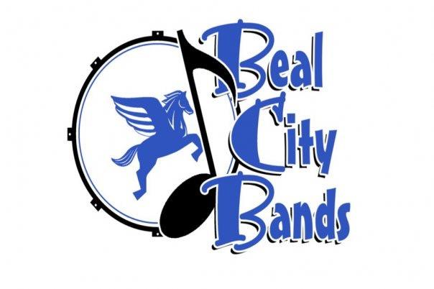
Beal City Public Schools
Visual, Performing and Applied Arts Pacing Guide - Music Appreciation
Module Three: Musicology: American Musical Theater
This module can run concurrently with any musicological modules
Week | Key Objectives | Content Expectations | Target Student Outcomes | Assessment and Rubrics
1-3 | Beginnings through Show Boat  • Origins in vaudeville, minstrelsy, extravaganza, follies, revue  • Important figures - composers, producers, actors  • Relevant performance practice trends  • Listen/view to authentic recordings | State Standards: 1, 2, 3, 4, 5  Visual, Performing & Applied Arts Guidelines: C.1, C.2, C.3, C.4, C.5, P.1, P.2, P.3, P.4, R.1, R.2, R.3, R.4 | • I will develop and improve my basic understanding of American musical theater and its importance and impact in American society. | • Computer-Aided Instruction  • Multimedia Presentation(s)  • Participation Grades  • Written Evaluations  • Teacher Evaluations
4-7 | The Golden Age  • Historical & social perspectives; correlation and response to and from music • Important composers/lyricists  • The role of story in musical theater development  • Listen/view to authentic recordings |  | • I will understand basic musical terminology and increase my musical vocabulary.
8-11 | Social Upheaval  • Historical & social perspectives; correlation and response to and from music  • Important composers/lyricists  • The role of political movements and its effect on the musical  • Listen/view to authentic recordings |  | • I will listen musically.
12-14 | The Fall and Resurrection of Broadway  • Historical & social perspectives; correlation and response to and from music  • Important composers/lyricists  • Separation of pop music and art music  • Economic troubles in New York and its effect  • Listen/view to authentic recordings |  | • I will be able to apply all musical concepts to my music: tone, intonation, technique, rhythm and interpretation.
15-18 | The Millenium and Beyond  • Historical & social perspectives; correlation and response to and from music  • Important composers/lyricists  • Modern Broadway musicals  • Separation of pop music and art music  • Listen/view to authentic recordings

